
Update date, xx xxxx

Visa Debit Card Dispute Management
PROCESS

October 1, 2026

Document Tracking and Control Table

Policy Owner | TBC
Approval Date | TBC
Version | TBC
Access Level | TBC
Policy Author | TBC
Subject Matter Expert(s) | TBC
Last Full Review Date | TBC
Update Date (changes were made but a full review was not necessarily conducted) | TBC
Review Frequency Requirement | TBC
Changes made | TBC
Stakeholders Impacted | TBC

Purpose
The Visa Debit Card Dispute Management Procedure guides the Growth, Payment Services, Fraud Prevention, and Finance teams in managing member-initiated Visa Debit Card disputes. It sets out a consistent approach for receiving and triaging dispute claims, gathering and assessing supporting documentation, issuing provisional credit, submitting and managing disputes through Central 1 and the Visa network, and resolving disputes and recovering funds where applicable. It also covers the roles and systems involved, the process flows, and the detailed procedures across the dispute management lifecycle.

Scope
This procedure applies to all team members involved in the intake, triage, investigation, submission, and resolution of member-initiated Visa Debit Card disputes, received through the following channels:
- Branch: occurs when a member visits Beem’s branch to dispute a Visa Debit Card transaction.
- Contact Centre: occurs when a member contacts Beem’s Growth Team by phone to dispute a Visa Debit Card transaction.
This procedure covers the five stages of the dispute management lifecycle:
Stage 1. Dispute Intake
Stage 2. Dispute Triage
Stage 3a. Case Preparation & Document Assessment
Stage 3b. Provisional Credit Issuance
Stage 4. Network Submission & Response
Stage 5. Resolution & Recovery

Roles and Systems
The following roles and systems support various activities within the Visa Debit Card Dispute Management Procedure.
Role / System | Responsibility
Growth Team | Front-line contact centre and branch staff who maintain contact with members, receive the member's dispute claim, verify the cardholder and impacted transaction(s), records dispute details. Where required, they perform initial account security actions, such as blocking and reissuing the card.
Payment Services Team | Investigates and manages non-fraud (recognized/authorized transactions) disputes referred by the Growth Team, prepares case documentation, submits eligible disputes to Central 1, and manages dispute outcomes and recoveries for non-fraud cases.
Fraud Prevention Department | Fraud Management / Fraud Specialists provide centralized expertise and coordination to support consistent fraud detection, escalation, investigation, response, recovery, and reporting practices across the organization. They are responsible for leading or coordinating fraud investigations and case management activities, supporting appropriate evidence and documentation practices, and enabling effective cross-functional coordination and governance visibility for significant fraud risks, trends, and incidents.  Key responsibilities may include:  - conducting or coordinating fraud investigations and case management activities,  - maintaining case documentation and supporting appropriate evidence handling practices,  - coordinating escalation, response, containment, and recovery activities with relevant operational and support functions,  - supporting reimbursement and remediation activities in accordance with established guidelines and approvals,  - monitoring fraud trends, emerging risks, and typologies to inform detection and control improvement opportunities,  - supporting fraud reporting, analytics, and governance visibility into material incidents and trends,  - providing operational guidance and input into training and awareness materials,  - coordinating with external parties (e.g., law enforcement, insurers, payment networks) where appropriate.
Finance Team | Validates and posts provisional credit to the member's account within pre-defined SLAs, tracks provisional credit aging and reversal, finalizes or reverses provisional credit based on the dispute outcome, and records recoveries, losses, fees, and general ledger entries.
Central 1 | Beem's financial services partner that receives completed dispute submissions and routes them, via PPJV, to the FIS Everlink Settlement team for submission to Visa Resolve Online (VROL) on Beem's behalf.
FIS Everlink (Everlink) | Beem's Visa Debit program processor. Submits dispute requests to Visa on Beem's behalf via VROL, and manages the pre-arbitration and arbitration cycle in accordance with Visa Rules and pre-defined processes and timelines.
CRM (Dynamics 365) | System of record used to create and track dispute cases and trigger both the ATM/POS trace (non-fraud) and Fraud Intake Form (FIF) (fraud) workflows.
DNA | Beem's core banking system used to review member and account information and apply card or account restrictions.

Stage 1: Dispute Intake Process (Growth)

4.1 Process Flow
The visual overview below provides the end-to-end process for a member contacting the contact centre or a branch to initiate a Visa Debit Card dispute. This stage is owned by the Growth Team.
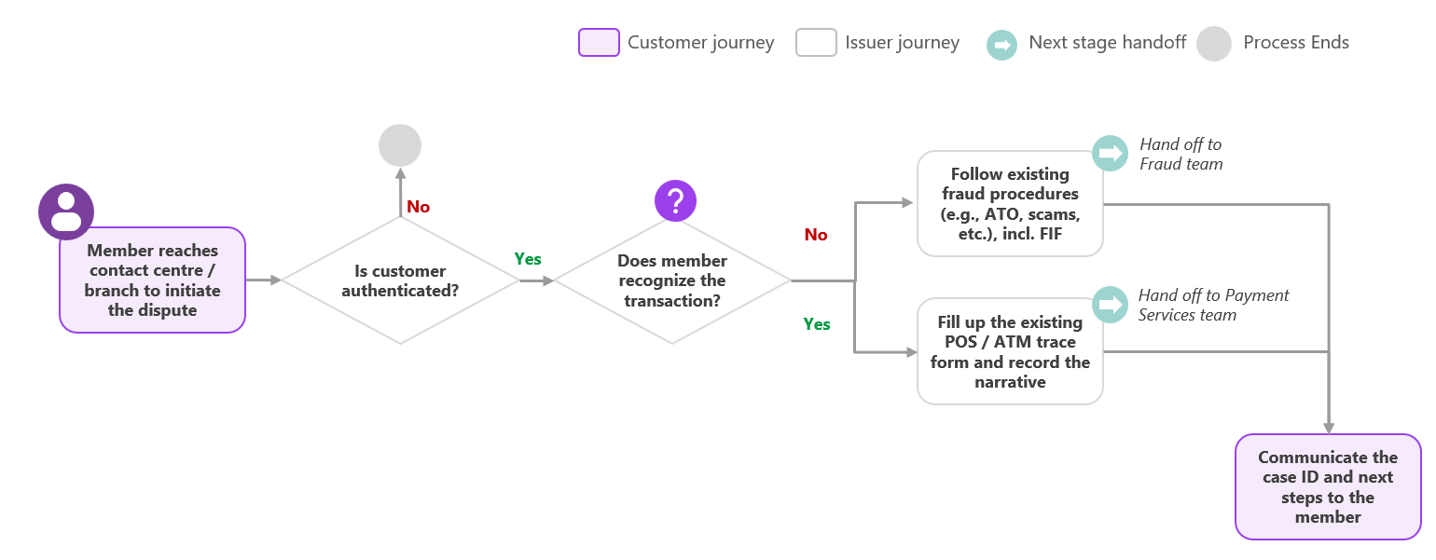

4.2 Procedure
The following procedure provides a step-by-step outline of the activities performed by Growth as part of dispute intake.

4.2.1 Authenticate the Member
Upon a member contacting the Contact Centre or a Branch to dispute a Visa Debit Card transaction, the Growth Team member should:
- Verify that the individual is the cardholder, in line with Beem's existing member authentication procedures [TBC — reference to be confirmed]. If the member cannot be authenticated, do not proceed with intake.

4.2.2 Confirm Transaction Posting and Locate the Transaction
The Growth Team member should:
- Confirm transaction posting – has the transaction posted to the member's account?
  - If not yet posted: follow Section 4.2.3 — Create the CRM Case, Steps 1–3 only (Case Details, Member Details, Transaction Details), to capture the pending transaction, then:
    - Advise the member that a dispute cannot be submitted while the transaction remains pending, and that Beem will follow up once it posts.
    - Once the transaction posts, proactively contact the member and proceed to Section 4.2.3, Step 4, to determine recognition and route the case.
  - If posted: proceed to Step 2.
- Locate the transaction the member is disputing in DNA, using the date, amount, and merchant name provided by the member.
  - If located: proceed to Section 4.2.3 — Create the CRM Case.
  - If it cannot be located: ask the member to reconfirm the date, amount, and merchant name, and search again. If the transaction still cannot be located, advise the member that Beem has no record of this transaction and a dispute cannot be initiated at this time.

4.2.3 Create the CRM Case
Open a new CRM Case and populate the following:
- Case Details (auto-populated): unique case ID, case creation date, current status, and owner.
- Member Details: member full name (search), member email (auto-populated based on name), member phone number (auto-populated based on name).
- Transaction Details (search for same transaction as Section 4.2.2): date, merchant, amount, and network type (e.g., Visa).
- Determine recognition of transaction: Determine whether the transaction is recognized or unrecognized. Below are guidance questions to help inform this determination:
  - “Did you authorize this transaction? Do you recognize the merchant name, even if you don’t recall the specific purchase?”
    - e.g., “No, I’ve never heard of this merchant” → potentially indicates fraud.
    - e.g., “Yes, I recognize the merchant and I made that transaction” → potentially indicates non-fraud.
  - “Could this charge be part of a recurring subscription or membership you may have forgotten about?”
    - e.g., “Oh, I think I signed up for a trial a few months ago” → potentially indicates non-fraud.
    - e.g., “No, I don’t have any subscriptions with this merchant” → potentially indicates fraud.
  - “Does the merchant name, amount, and date match what you expected? Sometimes merchants bill under a different name than their storefront (e.g., a parent company) — does that sound familiar?”
    - e.g., “Now that you mention it, that billing name does ring a bell” → potentially indicates non-fraud (a billing descriptor mismatch).
    - e.g., “No, that name means nothing to me” → does not resolve the mismatch; continue to the next question.
  - “Was the amount different from what you expected for a purchase you do recall making — for example, due to tax, tip, shipping, or currency conversion?”
    - e.g., “Oh, that could explain it — I did add a tip” → potentially indicates non-fraud (an expected variance).
    - e.g., “No, there’s no reason the amount should be different” → does not resolve the mismatch.
If, after asking the above questions, the member remains confident or adamant that they did not make the transaction, classify and route the case as Fraud.
Based on the member’s responses, the Growth Team member manually selects whether the transaction is recognized or unrecognized in the CRM. The CRM then automatically surfaces the applicable form within the case:
  - Recognized / Non-fraud: the ATM/POS Trace Request form appears. Proceed to Section 4.2.4 — ATM/POS Trace Request (Non-fraud).
  - Unrecognized / Fraud: the Fraud Intake Form appears. Proceed to Section 4.2.5 — Fraud Intake Form (Fraud).

4.2.4 ATM/POS Trace Request (Non-fraud)
The Growth Team member should then populate the remaining ATM/POS Trace Request fields within the case, including a note with the following details to help with the Payment Services Team investigation:
- Date/time of conversation with the member
- Method of instruction (branch / phone)
- Any other relevant details the member provided
- Dispute narrative – The following guidance questions may be used:
  - Reason for the dispute: "Were the goods or services not received or not as described, or were you charged twice or the wrong amount?"
  - Prior merchant contact: "Have you contacted the merchant to try to resolve the issue? If so, what was their response?"
    - E.g., "No, I haven't reached out to them yet." → recommend that the member try contacting the merchant first, as it may resolve the issue faster — however this is a recommendation, not a requirement.

4.2.5 Fraud Intake Form (Fraud)
Once the transaction is determined to be unrecognized:
The Growth Team member should then follow existing fraud procedures (e.g., Account Takeover, scams, etc.), including completing the Fraud Intake Form (FIF) — see the Fraud Intake Form Procedures.

